10 Steps to Building a Multi-Species Cover Crop Mix
“AKA Marlon’s Method”
Utah NRCS 340 Cover Crop IR
- In general, the goal is to aim for 1 to 1.3 million cover crop seeds in the mix weighing about 40 pounds total per acre for irrigated or higher moisture systems (for example 25-inch precipitation plus), or 650,000 – 1 million seeds in the mix per acre on dryland systems at about 30 lbs per acre. The reason for less seeds per acre in a dryland system is the reduced amount of precipitation, as it cannot support higher plant populations.

- To increase soil health benefits and to maximize biodiversity, consider both warm and cool season plants and when technically feasible (growing season applicable) aim for at least 2 to 4 different species from 4 different categories of cover crops from the cover crop calculator.
  - Legume
  - Grass
  - Brassica
  - Broadleaf

- To increase likelihood of establishment success, aim to have at least 1 – 3 species from each of the functional families listed below. For example, if a cover crop is being grown after harvest in cool climates, and growing season is short, warm season species are probably not applicable. Warm season cover crop mixes grown in the heat of the summer, they can have cool season species in the mix as the taller warm season species shade and cool the other species in the understory. Some people list 6 functional groups, they divide out the legume families. But for simplicity’s sake let’s just list four functional families
  - Cool season grass
  - Cool season broadleaf (includes legumes)
  - Warm season grass
  - Warm season broadleaf (includes legumes)

- Begin by selecting 2 to 4 species from each category into the cover crop spread sheet tool that will address goals and resource concerns of the producer. Start with assigning each species one pound of seed per acre. The goal is to give each species an opportunity to express itself and not have any one species dominate and crowd out the rest.

- A general rule is to keep total brassica (mustard family) rate to not more than two pounds total per acre.

Photo 1. Brassicas such as tillage radish have large leaf areas and are fast growing. They can outcompete other cover crop species if their seeding rates are too high. In this field, tillage radish was planted at the same rate as oats and winter peas. The seeding rate for tillage radish was too high and therefore outcompeted the other cover crops. Photo: Elisebeth Marks

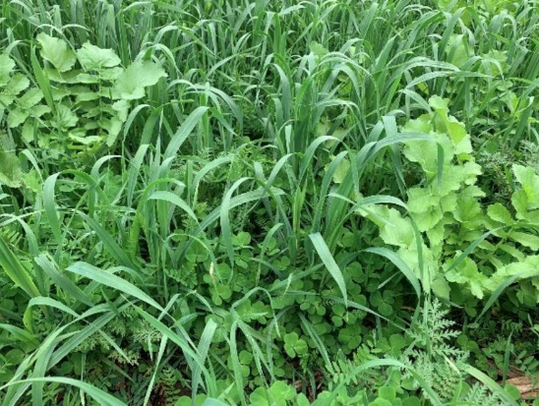

Photo 2. A mix with an ideal seeding ratio should look something like this – a diversity of species where not one is dominant and so they can all grow unimpeded. Photo: Elisebeth Marks

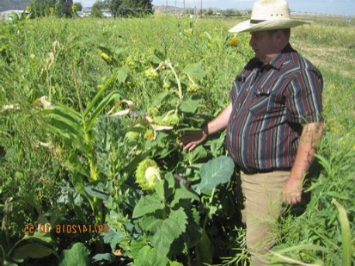
- Now, in the tool, add more pounds for the selected grasses and legumes in the mix. Add approximately 3-5 lbs for each species. Cover crop mixes with more grasses and legumes contribute to increasing diversity. As the mix becomes more diverse containing many separate species, reduce the seeding rate for each one in the tool to stay within desired seeds per acre. For example, if you are using oats in the mix at 20 lbs per acre, and you want to add barley, split each grass species to 10 lbs. If you additionally add triticale, then you would continue to decrease seeding rate equally for example 7 lbs each. Adjust for approximate equal amounts of seeds per acre, verses percentages, i.e. everything in a ten-way mix get 10% seeding rate. Be careful not to let one species be planted too thick or it will dominate the mix and not allow all the other species a chance to express themselves. Some of the small seeded cover crops are being coated, so alert, you can edit the seeds / pound in the tool.
Photo: Cameron Williams

- Select and adjust species based on the producer’s goals and objectives Resource Concerns. For example,
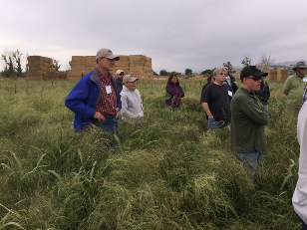
Touring innovative farmers with Teff in the mix.
  - Based on climatic conditions, what grows well during the time the cover crop will be planted and growing? Experience is a good teacher; visit innovative farms and cover crop plots in your region.
  - What is the cost of the different seeds and are they readily available in your location? (If species are expensive like peas and fava bean or hard to get, consider reducing pounds per acre, or choose alternative species during the initial, learning years).
  - Each year add a species that is new to the producer so they can learn about the species. Keep the new species at a lower rate for learning purposes.
  - Will the cover crop be grazed? If so, add in species that help fulfil the goals and objectives for livestock, that will provide adequate energy and protein for the animal diet. Don’t be scared to add species in a grazing mix that aren’t palatable. For example, cattle will eat the top 10% of the flax plant (seeds). The remaining stem (biomass) will be left to provide valuable soil armor.
  - Is the goal to increase organic matter and/or keep the soil covered? If so, add in species that have a higher Carbon: Nitrogen ratio such as grasses, flax, and sunflower etc. Many legumes and brassicas have low C:N ratios and will decompose very rapidly. Keep a well-balanced approach to the mix.
  - Is the goal to add or scavenge nitrogen? If so, add in legumes and deep-rooted species.
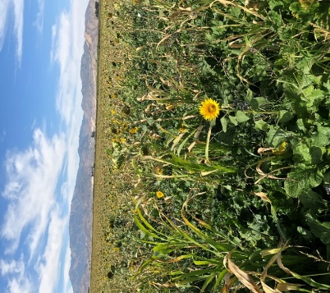
  - As the mix gets more diverse continue to reduce seeding rate of each species while allowing each specie to have the opportunity to express itself. For example: if adding 4 brassica species, give each species ½ pound, which equals the rule of no more than two pounds total.
  - Legumes are often the most expensive part of the mix. Try and have large seeded and small seeded cover crops like peas, vetch and clovers. This will help keep the mix from being too expensive. The big, seeded cover crops will break through the soil and allow the small seeded cover crops to follow in their path upwards.
  - If improved soil health and soil regeneration is an overarching goal of the farming operation, then diversity cannot be overstated.
12-way cover crop mix. Photos: Marlon Winger

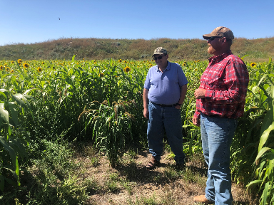
- You’ll notice that some seeds are small and weigh less, however most cover crop seeds have a very similar seed density. For example, winter wheat has a bushel weight of 60 lbs and turnips, even though a smaller seed have a 55 lbs bushel weight. Most are 50-60 lbs per bushel. That is why when we plant mixes, they seem to stay in solution in the seed drill box. When planted, the bigger seeds seem to punch through the soil and the smaller ones follow their path. When first learning to plant mixes don’t fill the drill box full. If there is concern that the mix will settle out during the planting operation, consider not filling the seed box completely full so that observations can be completed to gain confidence in uniform seed distribution. It is easier to refill than run out of seed.
Photo: Marlon Winger

- Because cover crop mixes are so unique, drill calibration is a must for added success.

- A cover crop mix dominated by small seeded species (mustards, clovers, teff) will generally not follow the rule of thumb of 40 lbs per acres and not more than 1.3 million pounds of seed per acre. One hundred pounds of wheat seed equals about 1 million seeds. Adjust accordingly realizing all the small seeds will not germinate and emerge through the soil. You can estimate pretty close on coated seed, if you know what percent of the seed is coated as an estimate of seeds per pound. Coated seed seems to have a higher survival rate than naked seed.
This philosophy is meant to provide general guidelines. This cover crop building method is not the only method out there but has worked for a lot of conservation planners and producers. There are a lot of “it depends” when building a cover crop mix. There is no better teacher than field observations, to say maybe we planted a species to heavy. It is ok to fail, as long as you fall forward. Find a mentor that can help guide you in creating alternative cover crop mixes. I was taught this philosophy by Jon Stika, NRCS area resource conservationist from North Dakota years ago.
There are many tools available to help you learn about each of the many cover crops traits that can be part of the mix.

Drill calibration tools:
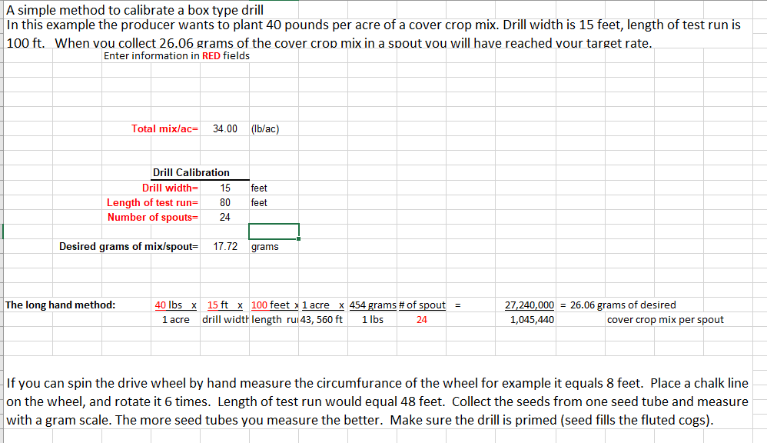

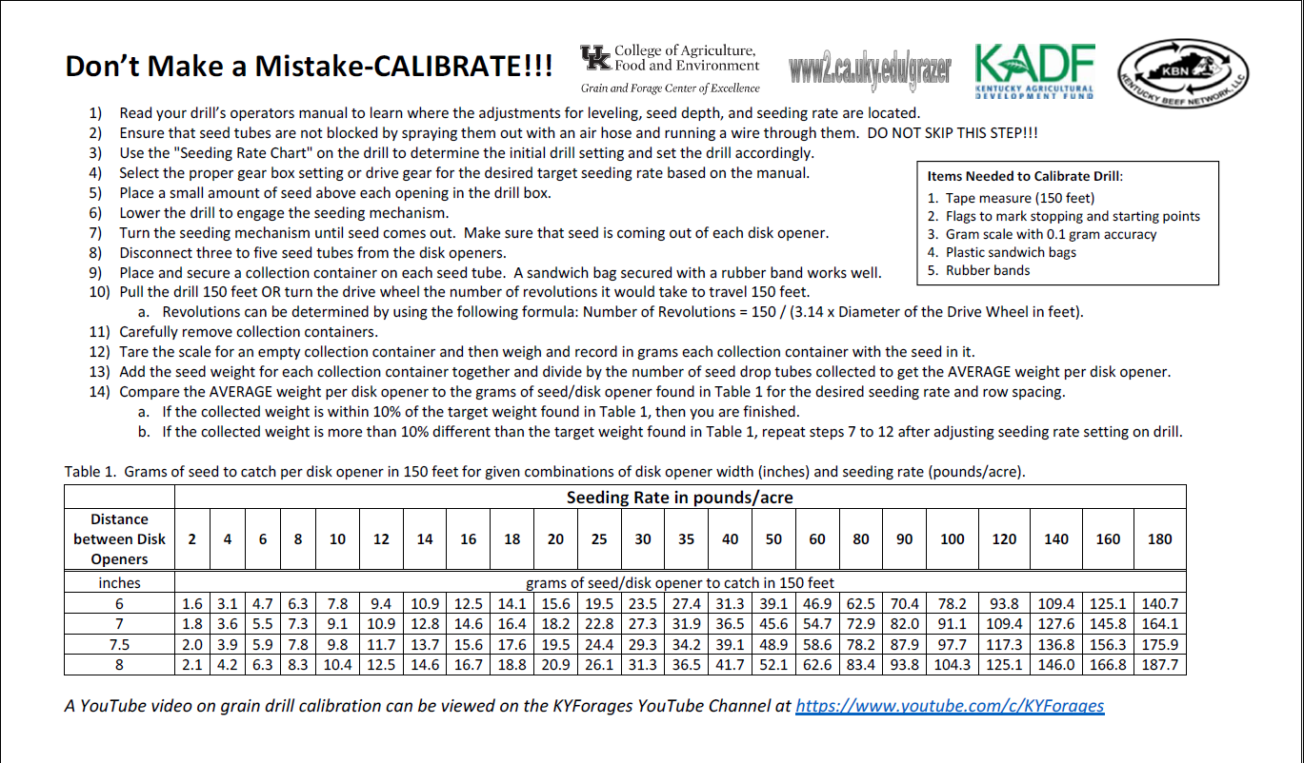

Example: Warm / Cool mix: (18 way mix)
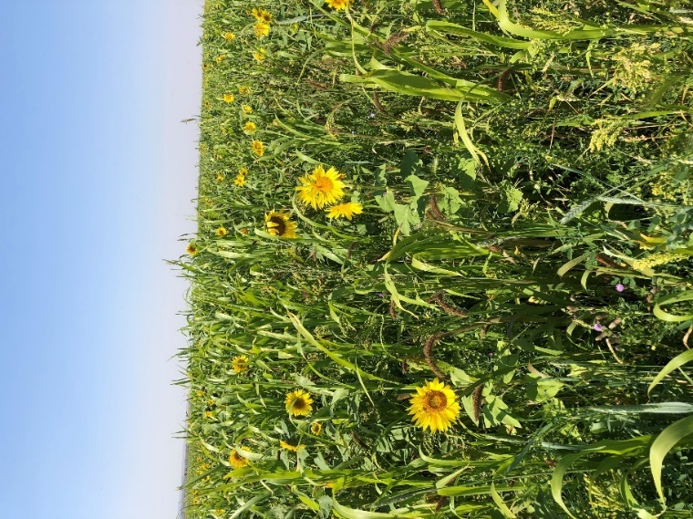
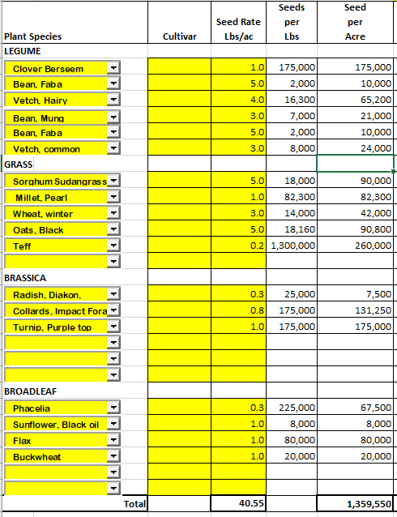
Photo: Marlon Winger

Example: Over wintering mix in North Carolina
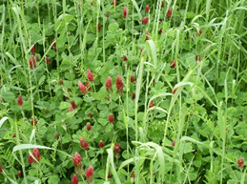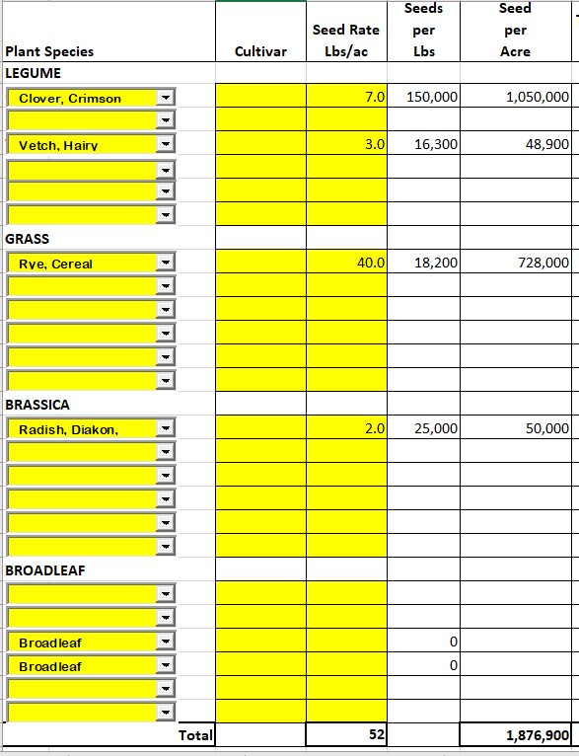
Photo: Nathan Lowder
Example Dryland over wintering mix, Wyoming
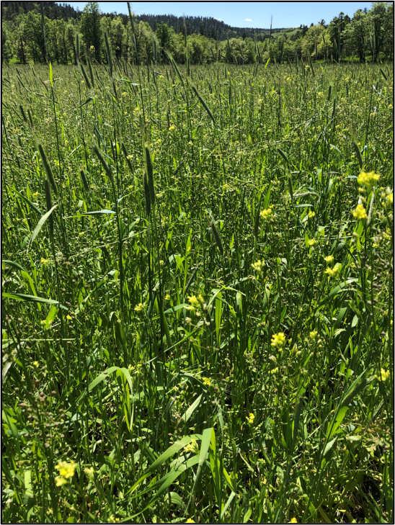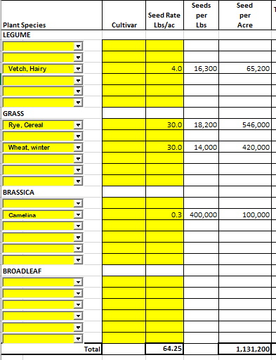
Photo: Marlon Winger
Supporting References:
Altieri, M.A. (1999). The ecological role of biodiversity in agorecosystems. Agriculture, Ecosystems and Environment 74:19-31.
Berns, K. (2023). Soil Health Resource Guide. GreenCoverSeed.com
Dabney, S.M., J.A. Delgado, and D.W. Reeves. (2001). Using winter cover crops to improve soil and water quality. Commun. soil sci. plant anal., 32(7&8), 1221-1250.
Eisenhauer, N. et.al. 2011. Plant Diversity Surpasses Plant Functional Groups and Plant Productivity as a Driver of Soil Biota in the Long Term. PLoS ONE 6(1):e16055. Doi:10.1371/journal.pone.0016055
Meimei, Chen, B. Chen, and P. Marschner. 2008. Journal of Environmental Sciences 20 (2008) 1231-1237.
Mintz, M. 2021. The Pluses and Minuses of Today’s Most Popular Cover Crops. No- Till Farmer.com.

